**Deploying an Online Movie Watching Application on Cloud**

**Course-end Project 1**

1. Create a website.

1. Create S3 static website.

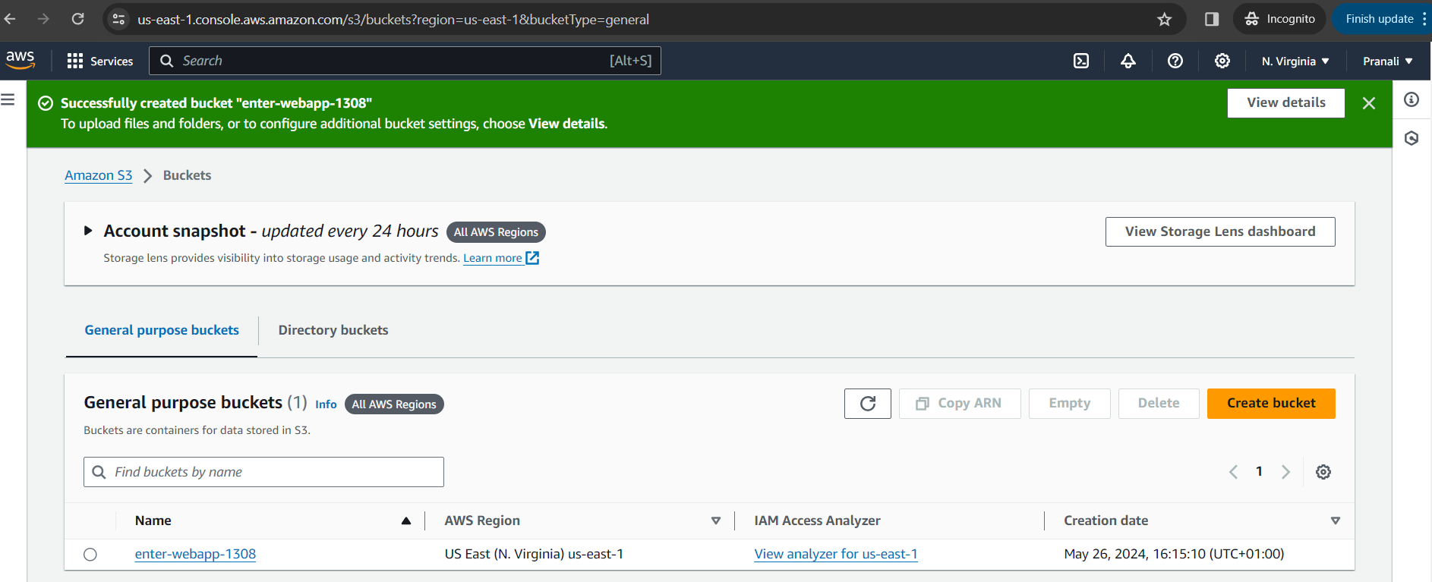

* 1. Bucket creation.

1. Create CloudFront distribution.

1. Create Route53 Hosted Zone and routing policy.

